INTRODUCTION OF ENDOBRONCHIAL ULTRASOUND and (CP) EBUS-TBNA

Venue: Macros Building Auditorium, Av. Manuel Olguin 501, Surco Lima, Peru

PROGRAM

Friday July 21th, 2017

14:30 - 15:00 | Registration. | Event Secretariat
15:00 - 15:30 | Welcome, Introduction, and learning objectives  Pre-Test and survey of practice experience. | P. Garcia
15:30 - 16:00 | EBUS – TBNA: Indications, diagnostic yield, complications. | A. Majid
16:00 - 16:30 | EBUS – TBNA: Acquisition, preparation and processing of specimens. Genotyping of non-small cell lung cancer. | R. Yung
16:30 - 17:00 | Mediastinal anatomy and lymph node structure (IASLC 8th Edition). | F. Tarrazzi
17:00 - 17:30 | EBUS – Chest CT – light Bronchoscopy: Correlations | O. Sánchez
17:30 - 18:00 | COFFEE BREAK.
18:00 -  18:20 | Surgical Staging in Mediastinum | F. Tarrazzi
18:20 - 18:40 | EBUS: Other applications. | A. Majid
18:40 - 19:00 | Practical Approach EBUS-TBNA: Clinic cases in Lung Cancer. | R. Yung
19:00 - 19:20 | Interactive Session: EBUS TBNA True/False exercises. | O. Sánchez
19:20 - 19:40 | The Essential EBUS Bronchoscopist  Post Course cognitive learning assessments
19:40 -20:00 | Wrap-up
20:00 -  21:00 | Multidisciplinary Symposium EBUS and Lung Cancer: In pursuit of Current Standard of Care

Saturday July 22th, 2017

8:00 a 10:30 | Hands-on training, FIRST Group:  3 workstations, 4 participants each station | Faculty in 3 stations.
8:00 a 10:30 | (1) EBUS Step by Step: Handling the scope and the needle. Low-fi simulation | Adnan Majid, Olivia Sánchez, Francisco Tarrazzi, Rex Yung, Pedro Garcia.
8:00 a 10:30 | (2) EBUS Step by Step: Handling the scope and the needle. Hi-fi simulation
8:00 a 10:30 | (3) Nodal and vascular mediastinal anatomy: Pattern recognition.
10:30 a 11:00 | COFFEE BREAK
11:00 a 13:30 | Hands-on training, SECOND Group:  3 workstations, 4 participants each station | Faculty in 3 stations.
11:00 a 13:30 | (1) EBUS Step by Step: Handling the scope and the needle. Low-fi simulation | Adnan Majid, Olivia Sánchez, Francisco Tarrazzi, Rex Yung, Pedro Garcia.
11:00 a 13:30 | (2) EBUS Step by Step: Handling the scope and the needle. Hi-fi simulation
11:00 a 13:30 | (3) Nodal and vascular mediastinal anatomy: Pattern recognition.

Faculty:

- Dr. Adnan Majid, MD, FCCP
Chief, Section of Interventional Pulmonology,
Director, Combined Harvard Interventional Pulmonology Fellowship Program,
Division of Thoracic Surgery and Interventional Pulmonology,
Beth Israel Deaconess Medical Center, Boston, MA
Associate Professor of Medicine, Harvard Medical School.
- Dr. Rex C. Yung, MD, FCCP
Pulmonary & Critical Medicine
Great Baltimore Medical Center
Past Director of Pulmonary Oncology and Director of Bronchology.
Johns Hopkins University, Oncology, Faculty Member

- Dr. Francisco Tarrazzi, MD, FACS, FCCP
Board-certified in General and Thoracic Surgery.
Memorial Healthcare System.
Memorial Cancer Institute, Hollywood, Florida.
- Dr. Olivia Sánchez-Cabral, MD, FCCP
Interventional Pulmonologist at Instituto Nacional de Enfermedades Respiratorias (INER)
Alta Especialidad Médica en Broncoscopia en INER
Profesor Titular del Curso de Neumología Intervencionista.
Universidad Autónoma de Coahuila Unidad Torreón.
Universidad Nacional Autónoma de México, Mexico City Area, Mexico
- Dr. Pedro Garcia-Mantilla, MD, FCCP
Pulmonologist - In Charge of Bronchoscopy Area
Division of Pulmonary Medicine
Guillermo Almenara Hospital - Peruvian Social Health Insurance, Lima, Peru
Master Instructor of Flexible Bronchoscopy - Bronchoscopy Education Project
World Association for Bronchology and Interventional Pulmonology - WABIP

Organized by:

Peruvian Association for Bronchology and Interventional Pulmonology
Asociación Peruana de Broncología y Neumología Intervencionista – APBNI

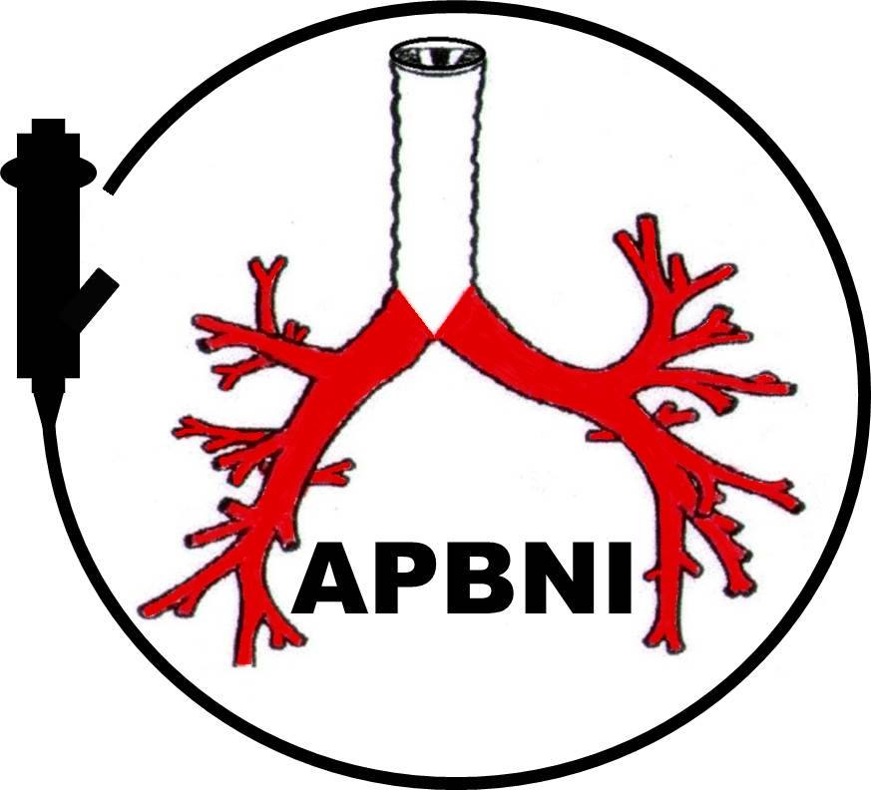

Supported by:
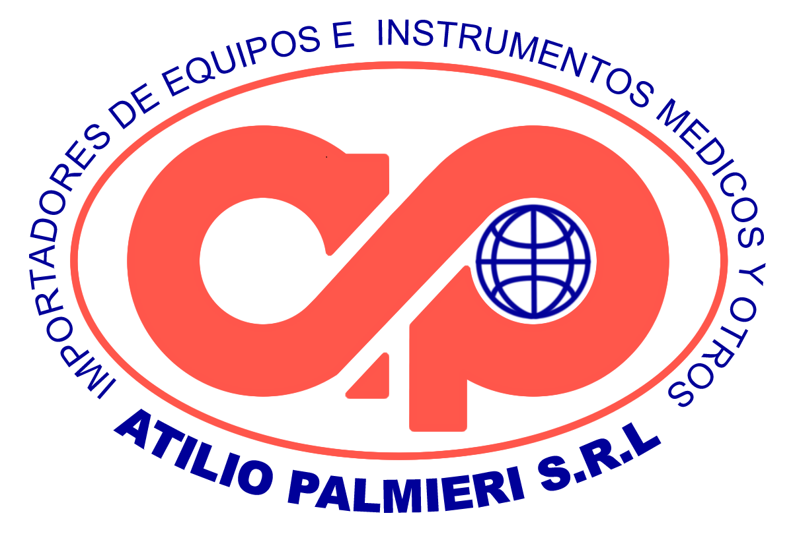


Notes:

- Didactic Lectures and Interactive Sessions for 24 participants.
- Hands-on training for two groups of 12 participants each. Workshops are divided into three workstations with 4 students each.

